**Summary Report of the 3rd S-129 Product Specification**

**Project Team Meeting**

**Busan, Korea 17 to 18 Sep 2018**

**Introductory remarks and opening of the meeting**

The chair opened the meeting by welcoming S-129 Project Team (PT) members as well as other delegates from the S-100 working group who were in Busan for other S-100 related work.

The introductory session included discussion of a draft meeting agenda, which was agreed as a starting point for the way the meeting should progress. As the meeting progressed and work expanded or contracted, the agenda was updated. The final agenda at Annex A reflects the timing and order of work recorded in this meeting report.

The S-100 working group chair added some introductory remarks and provided information about the S-100 related work that would take place on 18, 19 and 20 Sep.

Introductions were made – see Annex B for attendees.

As a part of the introductory session, it was mentioned that S-129 will need to be presented to the S-100 WG in Feb 2019 and then to the HSSC in May 2019 as Ed 1.0.0.

The S-100 WG chair suggested that the draft S-129 PS should be circulated to S-100 WG members for initial comments before formal presentation to the S-100 WG. This was noted and will be done via email as soon as a sufficiently completed draft of S-129 is available.

The S-129 PT will have carriage of further edits and changes as a result of testing up to Ed 2.0.0. After Ed 2.0.0 the change process becomes more formal.

Annex E contains several photographs of the 3rd S-129 PT meeting.

**Submitter to the IHO Geospatial Registry**

Discussion on who should be the submitter for the IHO GI resulted in agreement that Lindsay Perryman (AMSA) be the submitter and that Eivind Mong (Canada) would be available to assist Lindsay. Lindsay contacted the IHO secretariat during the meeting and made the necessary arrangements to become the S-129 submitter.

**Discussion too confirm S-129 encoding language**

The PT revisited the use of GML or 8211 encoding language for the S-129 PS. Discussions confirmed the previous decision the PT made that GML was the preferred encoding language for S-129.

The advantages of GML included web service usability, particularly noting the initial work done by KRISO to support S-129 has used GML (and changing to 8211 would result in significant re-work).

8211 was identified as being able to facilitate patch updates of S-129 files, however, this was considered to be excessive for S-129 as the use case does not require partial updates of S-129 information via patch files.

**S-129 Data Quality**

Initial discussion on the way that S-129 should deal with data quality concluded that an item could be included in the data model to address the time, horizontal and vertical elements of S-129 information. Later discussions when dealing with the data model and the data quality section of the S-129 PS, resulted in agreement that the data model need not include an item on data quality. Instead, it was agreed that the relevant section of the S-129 PS should contain an explanation of the way that data quality is dealt with in UKCM in general.

**PRIMAR presentation on S-102 data visualisation (3-D bathymetry/terrain)**

Svein Skjaeveland provided an informative and useful presentation outlining PRIMAR’s work on an S-102 demonstrator:

* The display contained information about data quality – where blue represented more trustworthy and red represented less trustworthy.
* A key use could be for passage planning to enable visualisation of narrow or shallow waterways.
* Another key use could be for the pilot and bridge crew exchange.
* The project will reach an end March 2019. A process has been started to raise funding for an extended 3-year project period, starting April 2019.
* The presentation is available on the IHO website.

The PT noted the potential for future follow-on work to include aspects of S-129, which could contribute towards S-129 testing activities.

**Presentation on testing of S-129**

KHOA and KRISO provided a joint presentation on S-129 testing including a description of work completed to date:

* A symbol editor had to be created to make S-129 symbols, with the control point symbol noted as needing redesign.
* The work highlighted the need for the data model items to be referenced in the use case material in the PS.
* Regarding the use of a data model for the UKCM route – S-421 was chosen over the RTZ option.
* The Feature Catalogue and Portrayal Catalogue should be populated as a priority to enable more rigorous testing.

Discussions concluded with the identification of several possibilities for further testing including, Shindong Digitech in Korea (mentioned by Seojeong Lee), PRIMAR (as part of the ongoing S-102 work), and OMC Int’l (in Korea and also using the Torres Strait UKCM system).

**Definitions of Dynamic and Static UKC**

The PT reviewed definitions of Static and Dynamic Under Keel Clearance and prepared updated definitions which were then provided to NIPWG (see Annex C).

**S-129 data model**

Seojeong Lee (KMOU) provided a description of the latest version of the data model to help the PT understand its components and their functions. Stemming from subsequent discussion the PT agreed that the GMSurface and GMPoint items should be specified as two-dimensional. This and several other minor changes were made to the data model when it was later reviewed in detail. The resultant latest version of the data model is now included in a new draft version of the S-129 PS.

**Detailed review of the draft S-129 Product Specification**

The PT reviewed in detail the draft S-129 PS and made several changes and updates to produce a new draft. The following actions were agreed to further progress the PS over the coming month:

**Section 1 – Overview (including 1.1, 1.2 and 1.3)**

The PT agreed the description of what S-129 aims to facilitate should be kept at a high level.

**Action PT3 - 1** – text in Sections 1.1, 1.2 and 1.3 to be tidied up (minor changes) – Lindsay P and Chris H

References and definitions will need to be updated as one of the last tasks.

**Section 1.4 – General S-129 Data Product Description**

**Action PT3 - 2** – Chris H to review/check and update Section 1.4 if needed

**Section 1.5 – Data product specification metadata**

The PT agreed this section is sufficiently complete

**Section 2 – Specification Scope**

The PT agreed this section is sufficiently complete

**Section 3 – Dataset Identification**

This section needs updating further.

**Action PT3 - 3** – Eivind M to update Section 3

**Section 4 – Data Content and Structure**

This section needs updating further.

**Action PT3 - 4** – KMOU (Kevin) and Chris H to update Section 4

**Section 5 – Feature Catalogue**

This section needs updating further.

**Action PT - 5** – Eivind M to update Section 5

**Section 6 – Dataset types**

The PT discussed and agreed this section needs updating using the headings currently used in Section 4.0, but with more concise text.

**Action PT3 - 6** – Chris H and Nick L to update using the headings currently used in Section 4.0, but with more concise text.

**Section 7 – Geometry**

The PT agreed this section is sufficiently complete.

**Section 8 – Coordinate Reference System (CRS)**

The PT agreed this section is sufficiently complete for the present, but it may need checking at a later stage.

**Section 9 – Data Quality**

This section was discussed in detail and agreed new draft text has been included.

**Action PT3 - 7** – provide the draft PS to the Data Quality Working Group along with a description of the scope of S-129 – Nick L

**Section 10 – Data Capture and Classification**

A subset of the data model needs to be included in this section which explains how to use the items in the data model. The DCEG from S-127 is a good example to use to help with preparing this section.

**Action PT3 – 8** – complete registration of the PC and FC – Lindsay P supported by Eivind M

**Action PT3 - 9** – after completion of PT3 – 8 KRISO to complete Section 10

**Section 11 – Maintenance and Update Frequency**

The PT agreed this section needs a quick check and update if needed.

**Action PT3 - 10** – Nick L and Chris H to check Section 11 and update if needed

**Section 12.0 - Portrayal**

The PT discussed the requirements for this section and agreed a short paragraph that refers to Annex D would suffice.

**Action PT3 - 11** – KMOU (Kevin) prepare a short paragraph that refers to Annex

**Section 13 – Data Product Format (encoding)**

**Action PT3 -12** – Section 13 to be completed by KMOU (Kevin) with assistance from Eivind M

**Section 14 – Data Product Delivery**

The exchange set structure diagram needs updating to align with S-100 Ed 4.

**Action PT3 - 13** – Chris H and Stephan E to review and update Section 14 using the use case information

**Action PT3 – 14** – Eivind M to update Section 14 to S-100 Ed 4 and make other updates as needed

**Section 15 – Metadata**

The exchange catalogue needs to be included in this section. The tables (from S-100 Ed 4 UML package) need to be amended to align with S-129 and included in this section.

**Action PT3 - 15** – Eivind M to amend Section 15 tables from S-100 Ed 4 UML package and include in Section 15 of S-129

**Action PT3 - 16** – KMOU (Kevin) – update the model of the metadata to reflect the updated tables from PT3 - 15

**Annex A – Data Classification and Encoding Guide**

**Action PT3 - 17** - KRISO to complete Annex A

**Annex B – Data Product Format (encoding)**

**Action PT3 - 18** – Eivind M to complete Annex B

**Annexes C and D – Feature and Portrayal Catalogues**

**Action PT3 - 19** – KMOU (Kevin) to complete these Annexes C and D

**Annex E – Validation Checks**

The PT agreed that S-122, S-123 and S-127 be used as a guide to help complete Annex E

**Action PT3 - 20** – PRIMAR (Svein S) to complete Annex E using S-122, S-123 and S-127 as a guide

The PT discussed over-all formatting and editorial tidying up of the draft S-129 PS.

Annex D contains a summary of agreed actions from the meeting and captures the names of those who will progress the actions. Suggested target dates for completing the actions are also included.

**Action PT3 - 21** – Briana S to carry out an overall formatting check of the document once the other drafting actions have been complete.

**Concluding remarks**

The PT discussed a timeline for completing the above actions and decided to aim for 31 Oct 18 to complete all the actions listed in this meeting report.

The Chair concluded the meeting thanking all members for their constructive engagement and in particular KHOA for their generous hosting of the meeting. Without KHOA’s support to provide a meeting venue, catering, IT support including a GoToMeeting facility, it would not have been possible to make the good progress that we have made.

Annex A

**Agenda for the**

**3rd S-129 Project Team Meeting 17-18 September 2018**

**Venue:**

Paradise Hotel

1408-5 Jung-dong Haeundae-gu,

Busan, Republic of Korea

**Session 1 – Monday 0900-1030**

1.1 Welcome and introductions (All)

1.2 Organisational arrangements and meeting expectations (Chair)

1.3 Program outline (Chair)

1.4 Review of minutes of last meeting(s) (All)

1.5 Update on progress since last meeting (All)

**Session 2 – Monday 1050-1200**

2.1 Discussion on dynamic changes and uncertainty information (All)

2.2 Presentation: S-102 Demonstrator (Svein Skjaeveland)

2.3 Presentation: S-129 UKCM Test (KHOA)

**Session 3 – Monday 1330-1500**

3.1 S-129 Testing (KHOA)

3.2 Data model review (KMOU)

**Session 4 – Monday 1450-1700**

4.1 S-129 data model review (All)

**Session 5 – Tuesday 0900-1030**

5.1 S-129 data model

5.2 Definitions of static and dynamic UKCM

5.3 S-129 PS review (All)

**Session 6 – Tuesday 1100-1230**

6.1 S-129 PS review (All)

**Session 7 –Tuesday 1330-1500**

7.1 S-129 PS review (All)

**Session 8 – Tuesday 1530-1700**

8.1 Summary of actions and concluding discussions (Chair)

Annex B

**Meeting attendees**

**Day 1**

**Name Organisation**

Eivind Mong Canadian Coast Guard

Yong Baek KHOA

Sewoong OH Kriso (+ 5 others)

Robert Sandvik ECC

Brianna Sullivan University of New Hampshire

Svein Skjaeveland ECC & PRIMAR

Tony Pharaoh IHB

Tom De Puyt ESRI

Hugh Astle Teledyne Caris

Jonathan Pritchard IIC

Julia Powell NOAA

John US waterways (working with S-124, S-112)

Ed Kuwalec IIC

Stefan Engström FTA

Hyo-seung Kim (Kevin) KMOU

Seojeong Lee KMOU

Hannu Peiponen FFOY

Nick Lemon AMSA

Lindsay Perryman AMSA

Martin Park KHOA

Chris Hens OMC Int’l (via GoToMeeting)

**Day 2**

**Name Organisation**

Nick Lemon AMSA

Lindsay Perryman AMSA

Dong Woo Kang KRISO

Hyua Soo Choi KRISO

Stefan Engstrom Finish Transport Authority

Eivind Mong CCG

Briana Sullivan UNH

Seojeong Lee KMOU

Svein Skjaeveland PRIMAR

Chris Hens OMC Int’l (via GoToMeeting)

Hyoseung Kim (Kevin) KMOU

Ed Weaver WR Systems (via GoToMeeting)

Annex C

**Result of S-129 Project Team discussion on definitions of static and dynamic UKCM**

**(17 and 18 Sep 2018)**

1. Use of the words “static” and “dynamic” was agreed as being readily understandable due to the existing uses of the words.
2. The S-129 PT further developed definitions of Static and Dynamic Under Keel Clearance Management as follows:
   1. Static Under Keel Clearance Management — A method based on rules that use a vessel’s static draught measurements and predicted tidal or water level information to estimate a vessel’s under keel clearance when underway in a depth constrained waterway. Static Under Keel Clearance Management approaches do not involve real-time interaction between vessels and shore-based service providers.

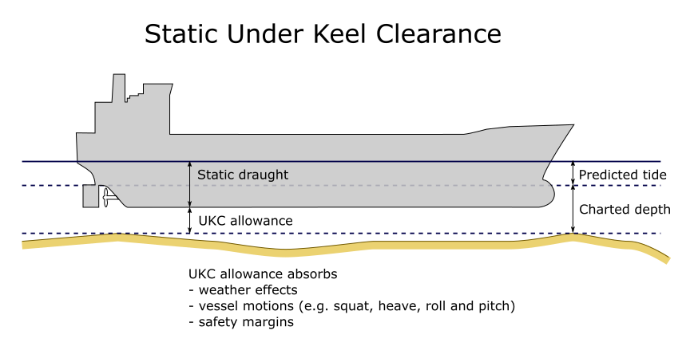

* 1. Dynamic Under Keel Clearance Management System — A system that typically involves interaction between vessels and shore-based service providers and which calculates a vessel’s under keel clearance. Dynamic Under Keel Clearance Management Systems use sophisticated models and real-time met-ocean inputs to produce vessel-specific services (e.g. tidal windows, routes, no-go and almost no-go areas) to ensure minimum under keel clearances are maintained.

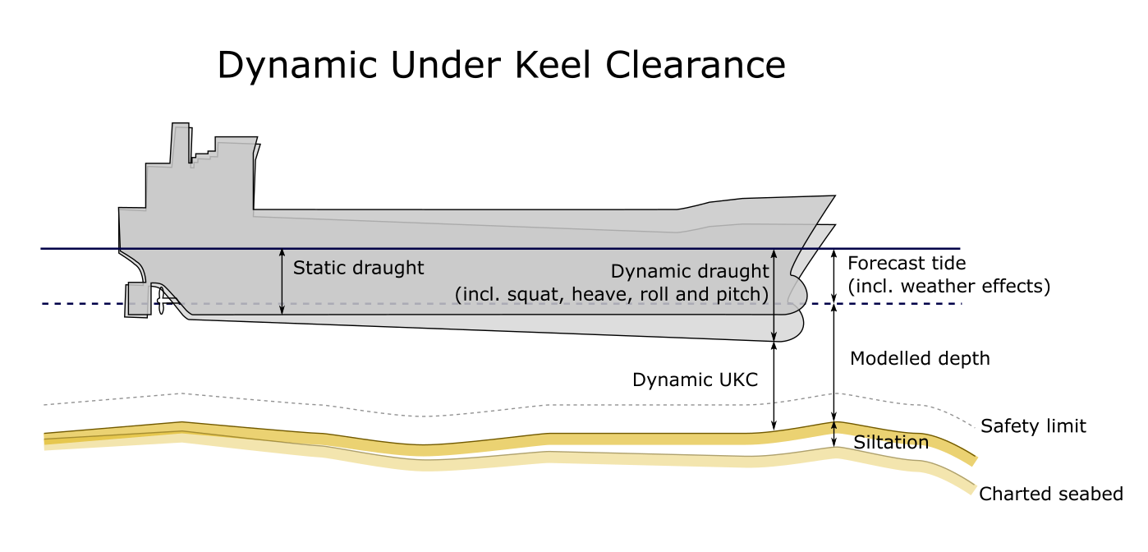

Annex D

**3rd S-129 PT Meeting – Table of Actions**

|  |  |  |  |
| --- | --- | --- | --- |
| **Action** | **Description** | **Allocated to** | **Due by** |
| PT3 - 1 | text in Sections 1.1, 1.2 and 1.3 to be tidied up (minor changes) | Lindsay P and Chris H | 05 Oct |
| PT3 - 2 | review/check and update Section 1.4 if needed | Chris H | 05 Oct |
| PT3 - 3 | update Section 3 | Eivind M | 11 Oct |
| PT3 - 4 | update Section 4 | KMOU (Kevin) and Chris H | 12 Oct |
| PT3 – 5 | update Section 5 | Eivind M | 18 Oct |
| PT3 – 6 | update using the headings currently used in Section 4.0, but with more concise text | Chris H and Nick L | 05 Oct |
| PT3 – 7 | provide the draft PS to the Data Quality Working Group along with a description of the scope of S-129 | Nick L | 15 Nov |
| PT3 - 8 | Complete registration of the PC and FC (supports Section 10) | Lindsay P supported by Eivind M | 18 Oct |
| PT3 – 9 | After completion of PT3 – 8 complete Section 10 | KRISO | 26 Oct |
| PT3 – 10 | check Section 11 and update if needed | Nick L and Chris H | 05 Oct |
| PT3 – 11 | prepare a short paragraph that refers to Annex D | KMOU (Kevin) | 10 Oct |
| PT3 – 12 | Section 13 to be completed | KMOU (Kevin) with assistance from Eivind M | 19 Oct |
| PT3 – 13 | review and update Section 14 using the use case information | Chris H and Stephan E | 11 Oct |
| PT3 – 14 | update Section 14 to S-100 Ed 4 and make other updates as needed | Eivind M | 25 Oct |
| PT3 – 15 | amend Section 15 tables from S-100 Ed 4 UML package and include in Section 15 | Eivind M | 25 Oct |
| PT3 - 16 | update the model of the metadata to reflect the updated tables from action PT3 - 15 | KMOU (Kevin) | 26 Oct |
| PT3 – 17 | complete Annex A | KRISO | 26 Oct |
| PT3 – 18 | complete Annex B | Eivind M | 25 Oct |
| PT3 – 19 | complete these Annexes C and D | KMOU (Kevin) | 26 Oct |
| PT3 – 20 | complete Annex E using S-122, S-123 and S-127 as a guide | PRIMAR (Svein S) | 25 Oct |
| PT3 – 21 | carry out an overall formatting check of the document once the other drafting actions arecomplete | Briana S | 31 Oct |

Annex E

**3rd S-129 PT Meeting Photographs**

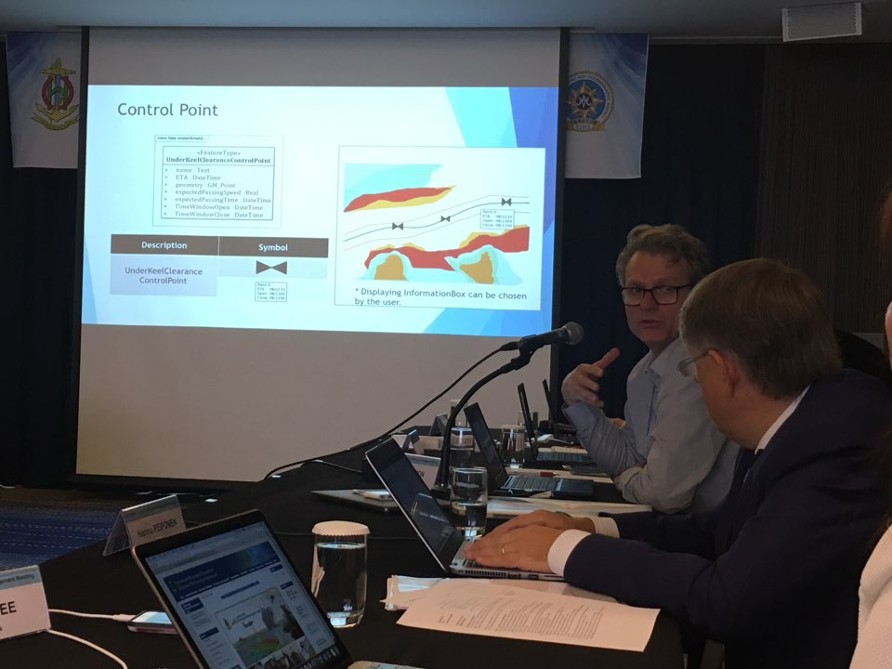

Day 1

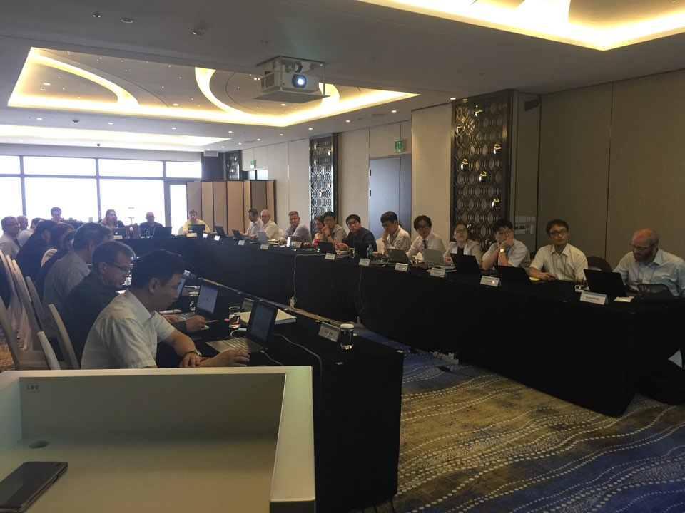

Day 1

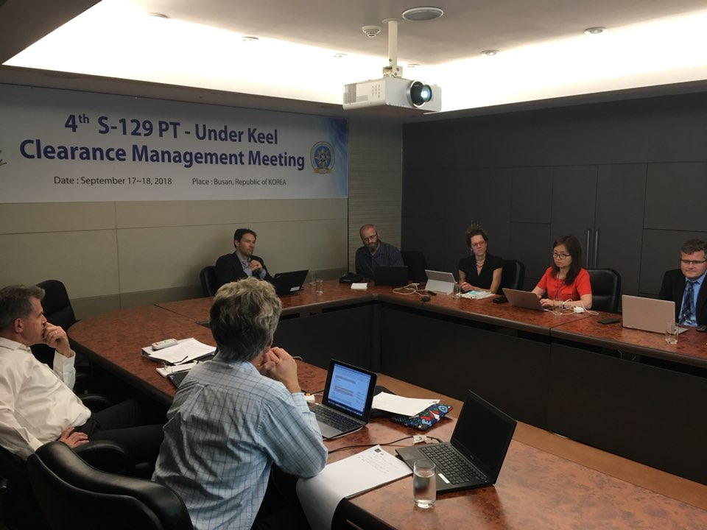

Day 2